Facts for the trade press
for the MACH 2024 exhibition
Refining surfaces with the mass finishing technology

Walther Trowal:
The mass finishing technology refines surfaces gently and efficiently
Haan/Germany, February 1, 2024 Walther Trowal displays its equipment for finishing the surfaces of general and high-value components at the MACH 2024 exhibition. These versatile finishing technologies are suitable for deburring, edge radiusing, cleaning, surface smoothing and high-gloss polishing. In addition, the company presents a centrifuge for eco-friendly cleaning and recycling of the process water.
Walther Trowal shows a centrifugal disc finishing machine of the model range TT…A/2C for finishing the surfaces of small, mass-produced parts. The so-called “double-batch” system allows the processing of one batch, whilst a second batch is passing through a separation system, where the finished parts are separated from the processing media. The simultaneous operation of two separate process stages minimizes unproductive idle times and allows high efficiency plus maximum throughput. The TT..A/2C systems are very compact so require little space.
Walther Trowal also presents its CB circular vibrator, which can be easily integrated into interlinked and automated manufacturing operations. Optional technical characteristics like the parts loading chute on the outside of the processing channel and the so called “gate clearing” feature greatly facilitate the integration of these machines into automated production processes and guarantees batch integrity.
Since most mass finishing processes require the addition of water and suitable liquid processing compounds, the finished parts often undergo a drying operation. Therefore, Walther Trowal also displays a G drier that not only dries the parts, but also generates a light polish. The machine can be combined with upstream mass finishing systems in batch as well as continuous feed operations.
Walther Trowal develops complete surface finishing solutions that can be seamlessly integrated into the production flow of the customers’ manufacturing operations. Since the effective handling of the process water is an integral part of most mass finishing operations, at the MACH 2024 exhibition the company also demonstrates a ZM basket centrifuge that allows the cleaning and recycling of the mass finishing process water in a closed-loop system.
Walther Trowal at the MACH 2024 exhibition:
Birmingham/Great Britain, April 15 – 19, 2024
Hall 6, booth number 432
Contact:  Walther Trowal Ltd  Martin Payne  Matrix Point  120 Devon Street  Birmingham B7 4SL / Great Britain  Tel: +49 2129 571-209  www.walther-trowal.com  m.payne@walther-trowal.co.uk | Contact for the editor:  VIP Kommunikation  Dr.-Ing. Uwe Stein  Dennewartstraße 25-27  52068 Aachen / Deutschland  Tel: +49 241 89468-55  www.vip-kommunikation.de  stein@vip-kommunikation.de
Photos
Download of high resolution photos: press photos Walther Trowal
Photo 1: A production line with rotary vibrators, model CB 300  File name:  WT-CB-Verkettet-SKF-4.jpg | 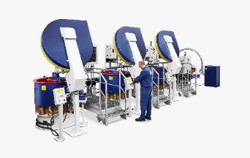
Photo 2: A Turbotron (TT) centrifugal disk finishing system in double batch version  File name:  Walther-Trowal-TT_A_2_C-(8).jpg | 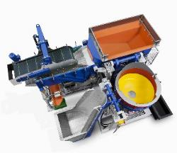
Photo 3: At the exit of their processing channel rotary vibrators are equipped with an integrated separation screen that allows the separation of the finished work pieces from the processing media.  File name:  WT_Schleifmittel_AF-0621-4673.jpg | 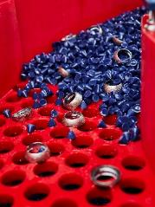
Photo 4: Controlling the surface quality of a work piece after the finishing process in a circular vibrator.  File name:  WT-CB-Verkettet-SKF-5.jpg | 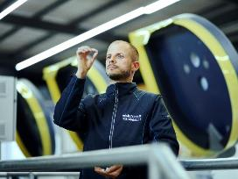
Copyright: Company photos Walther Trowal

About Walther Trowal
Surface finishing technologies from the inventor of the “Trowalizing” process
Since 1931 Walther Trowal has been developing and producing systems for the refinement of surfaces. Initially focusing exclusively on mass finishing – the term “Trowalizing” originated from the company’s cable address “Trommel Walther” – Walther Trowal has continuously expanded its product portfolio.
Over time the company has developed a broad range of machinery and systems for mass finishing, shot blasting and coating of mass-produced small components.
With the invention of new systems like, for example, drag finishing and the development of special finishing methods for 3D printed components, the company has proven its innovative capabilities again and again.
Walther Trowal develops and implements complete surface treatment solutions that can be seamlessly integrated into linked production systems existing at the customers. This includes the entire process technology, perfectly adapted to the specific surface finishing requirements of the work pieces: Equipment and the respective consumables always complement each other in a perfect manner.
Each individual work piece and each manufacturing process must meet special technical requirements. That is why the experienced process engineers in our test lab, in close cooperation with the customers, develop the optimal process technology for the finishing task at hand. The result: Work piece surfaces that meet exactly the required specifications … with short processing times and a high degree of consistent, repeatable results.
Walther Trowal is one of the few manufacturers who develops and produces all machines and mass finishing consumables in-house … including ceramic and plastic grinding and polishing media as well as compounds.
The company’s equipment range also includes all kinds of peripheral equipment for handling the work pieces like lift and tip loaders, conveyor belts and roller conveyors, in addition, special driers for mass finishing applications and, last-but-not-least, systems for cleaning and recycling of the process water.
With its exchange program for wear items like work bowls, which are part of a continuous recycling program, Walther Trowal conserves valuable resources and, thus, makes a significant contribution towards sustainability in the field of industrial production. Quick technical support and the global repair and maintenance service ensure high uptimes for our equipment.
Walther Trowal serves customers in a wide range of different industries all over the world, for example, automotive, aerospace, medical engineering and wind power.

